S3 firmware updated instruction
1.checking hardware VID&PID of SONATA HD
1)please click “start” button as below in PC.

2）Click “control panel” .
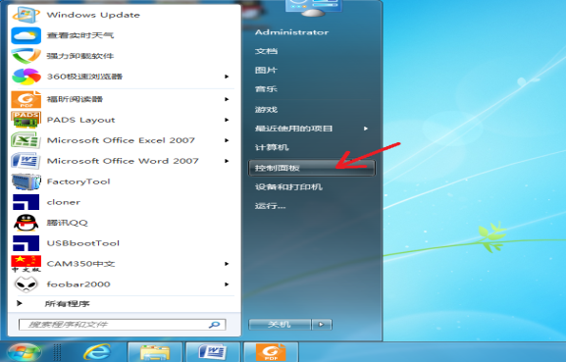

3）Click “device manager”
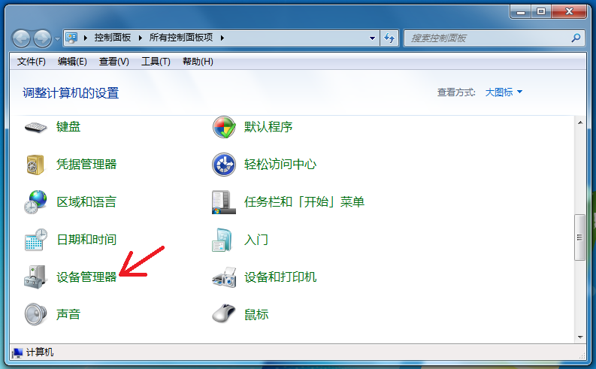
4）Click “human interface devices”
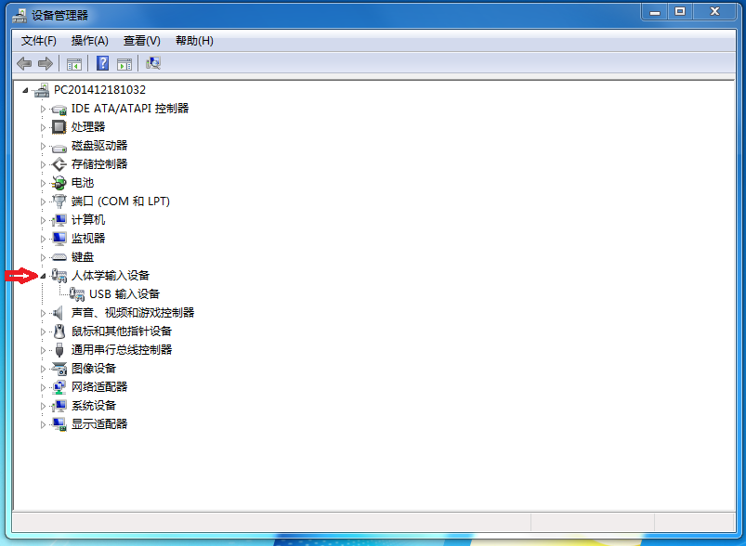
5）Plug in the Type_C Via USB 2.0，connect the Sonata HD cable with your PC.(When connecting with PC for the first time, it will install the driver automatically, and the PC will show it is installed the driver successfully as below showing).
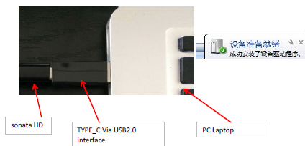

6）When connecting the SONATA HD with PC, it will appear one more “USB imput device”
(Attention: different PC will show different qty of “USB imput device”, find the right USB device, if not, it will be failed to be updated later)
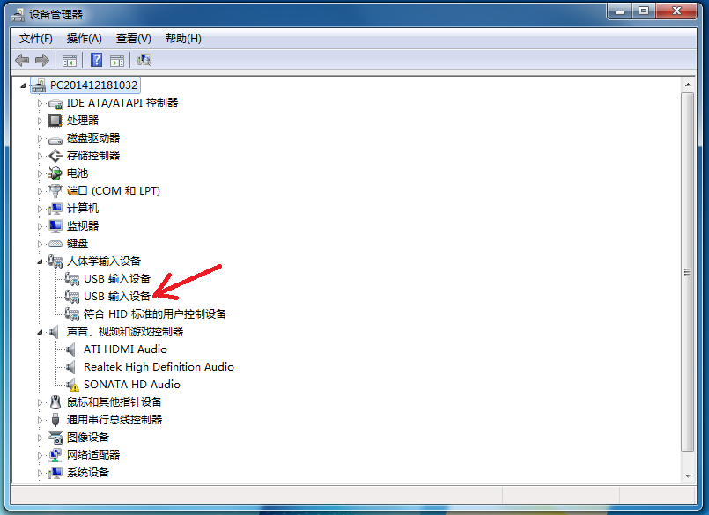
7）After finding the right “USB imput device”, click right button of mouse.
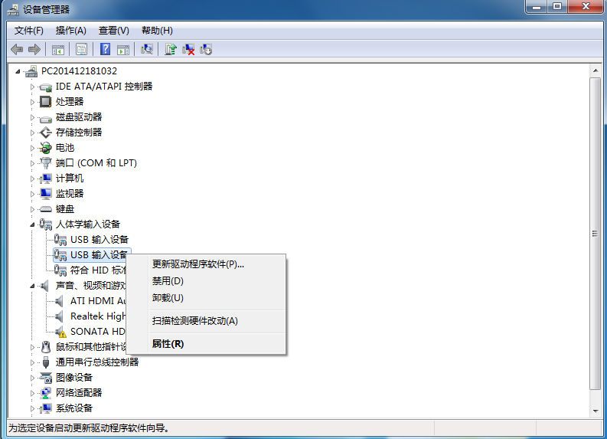
8）Then choose “attribute”.
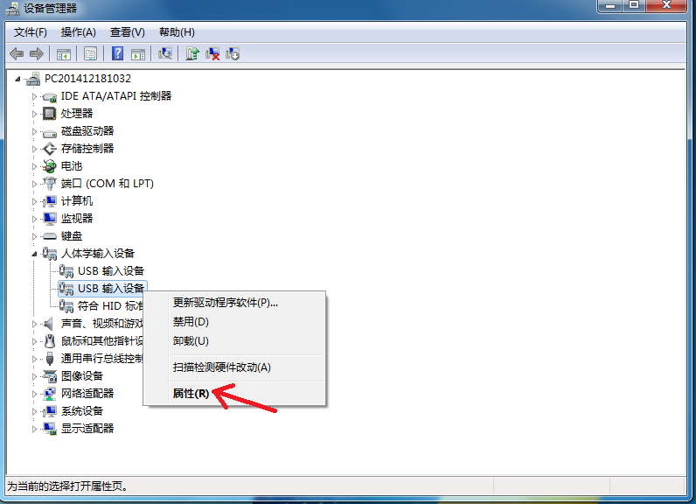

9）Then in below page, please choose “detailed information”.
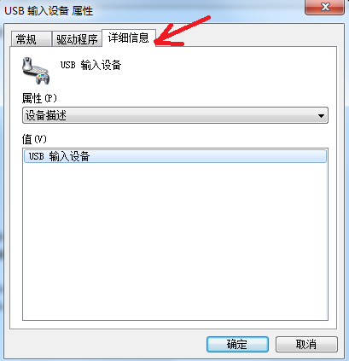
10）Choose “hardware ID”
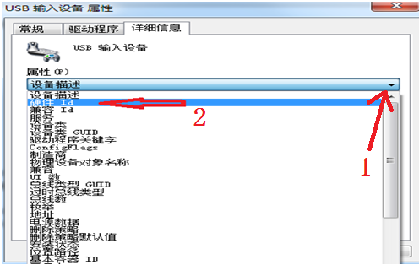
11）Remember VID&PID code, it will be used in later updated firmware.
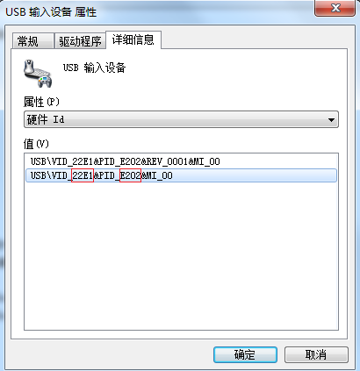
2．S3 firmware updated
- After unzipping the firmware zip file, and double click it as below red arrow showing.
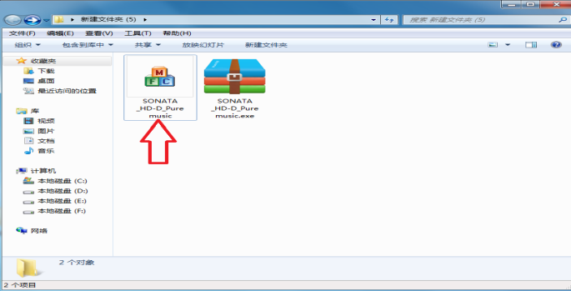
- Then it will appear below page, and click “ yes”
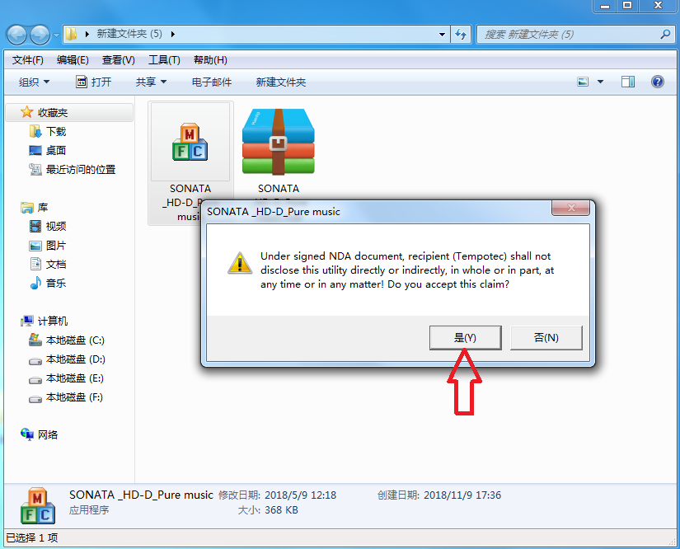
- Open the updated tool as below:
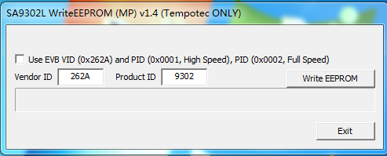
- And write right VID&PID in the box.(attention: above VID&PID code only as sample can’t refer to.)
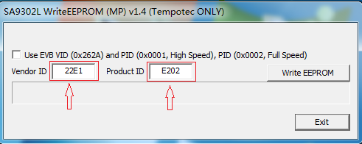

5）Click“ write eeprom”
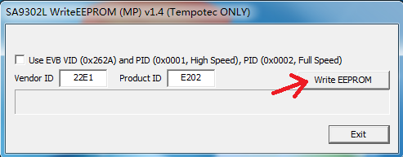
6）Then it will show below page. Attention: unplug Sonata HD from USB, then re-plug in it again, then click “confirm” button.
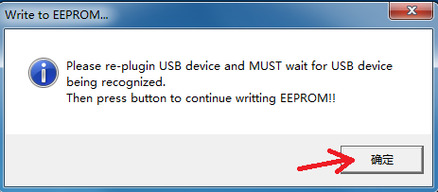
7）Then it will start to update like below:
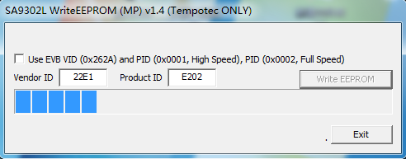

8）Then press “confirm”, HD updated finished.
弹出如下窗口，点击“确定”，升级完成。
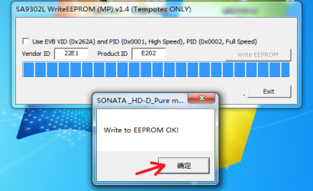
9）Click “Exit”
